

Software Requirements Specification

**Version1.0**

**Anh Minh**

**12/11/2019**

**VERSION HISTORY**

|  |  |  |  |  |  |
| --- | --- | --- | --- | --- | --- |
| **Version #** | **Implemented**  **By** | **Revision**  **Date** | **Approved**  **By** | **Approval**  **Date** | **Reason** |
| 1.0 | Anh Minh | 12/11/2019 |  |  | Create Document SRS version 1.0 |
|  |  |  |  |  |  |
|  |  |  |  |  |  |
|  |  |  |  |  |  |

**Table of Contents**

**I. USE CASE DIAGRAM 3**

**II. USE CASE LIST 4**

**III. USE CASE DESCRIPTION 5**

1. **USE CASE DIAGRAM**
2. **Use Case Diagram General (chua hoang thien)**

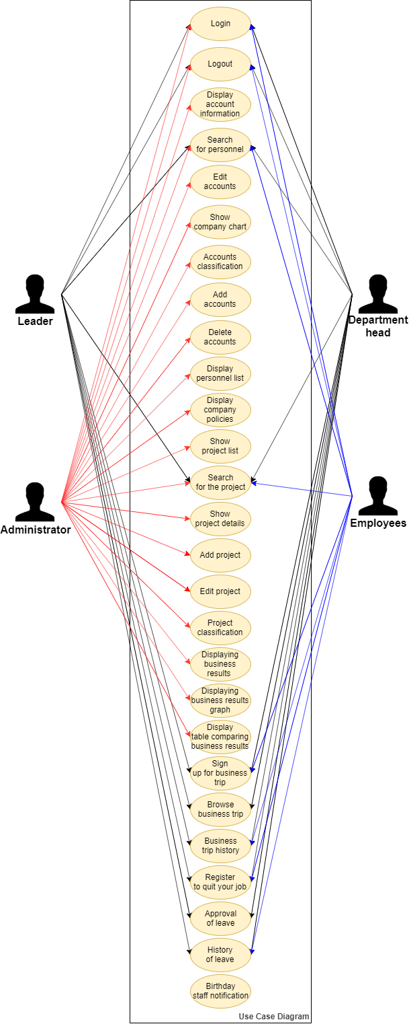

1. **Use Case Diagram Leader**
2. **Use Case Diagram Department Head**
3. **Use Case Diagram Admin**
4. **Use Case Diagram Employees**
5. **USE CASE LIST**

List all use cases following this template:

|  |  |  |  |  |
| --- | --- | --- | --- | --- |
| **#** | **UC ID** | **UC Name** | **Description** | **Actors** |
| 01 | UC01 | Login |  |  |
| 02 | UC02 | Logout |  |  |
| 03 | UC03 | Display account information |  |  |
| 04 | UC04 | Search for personnel |  |  |
| 05 | UC05 | Display personnel list |  |  |
| 06 | UC06 | Show company chart | Admin show company chart after having data from the internal company | Admin |
| 07 | UC07 | Display company policies |  |
| 08 | UC08 | Add account | Admin add new user |
| 09 | UC09 | Delete the account | Admin the delete of users from the system |
| 10 | UC10 | Edit account | Admin the editing of user information |
| 11 | UC11 | Account classification |  |  |
| 12 | UC12 | See the project list |  |  |
| 13 | UC13 | Search for the project |  |  |
| 14 | UC14 | Show project details |  |  |
| 15 | UC15 | Add project |  |  |
| 16 | UC16 | Edit the project |  |  |
| 17 | UC17 | Delete the project |  |  |
| 18 | UC18 | Project classification |  |  |
| 19 | UC19 | Displaying business results |  |  |
| 20 | UC20 | Displaying business results chart |  |  |
| 21 | UC21 | The table shows the comparison of business results |  |  |
| 22 | UC22 | Sign up for business trip |  |  |
| 23 | UC23 | Approve business trip |  |  |
| 24 | UC24 | History of business trips |  |  |
| 25 | UC25 | Register for leave |  |  |
| 26 | UC26 | Approved  sabbatical leave |  |  |
| 27 | UC27 | History of leave |  |  |
| 28 | UC28 | Notice of employee's birthday |  |  |

1. **USE CASE DESCRIPTION**
2. **Login**

|  |  |  |  |
| --- | --- | --- | --- |
| **Use Case ID:** | UC01 | | |
| **Use Case: Name:** | Login | | |
| **Created By:** |  | Created By: |  |
| **Date Created:** |  | Date Created: | 12/11/2019 |
| **Actors:** |  | | |
| **Description:** |  | | |
| **Trigger:** |  | | |
| **Pre-conditions:** |  | | |
| **Post-conditions:** |  | | |
| **Normal Flow:** |  | | |
| **Alternative Flows:** | Không có | | |
| **Exceptions:** | Không có | | |
| **Business Rules** |  | | |

1. **Logout**
2. **Logout**
3. **Logout**
4. **Logout**
5. **Show company chart**

|  |  |  |  |
| --- | --- | --- | --- |
| **Use Case ID:** | UC06 | | |
| **Use Case: Name:** | Show company chart | | |
| **Created By:** | Quốc Nhân | Created By: |  |
| **Date Created:** | 12/11/2019 | Date Created: | 12/11/2019 |
| **Actors:** | Admin | | |
| **Description:** | Use case allows admin show chart company | | |
| **Trigger:** | User opens the 'organizational chart' interface | | |
| **Pre-conditions:** | * The user has logged in to the system with the User account * App with information 'organizational chart' | | |
| **Post-conditions:** | Success:   * User viewable 'organizational chart'   Failure:   * User not viewable 'organizational chart' | | |
| **Normal Flow:** | 1. User login to the system 2. The system displays the homepage information 3. User click on 'view information' 4. The system displays the page 'view information' 5. User click on 'organization chart' 6. Display system 'organizational chart' 7. Use case ends. | | |
| **Alternative Flows:** |  | | |
| **Exceptions:** | Input:   * The user entered the wrong account name or account information. * User entered the wrong format. | | |
| **Business Rules** | On this page users can view 'organizational chart' | | |

1. **Display company policies**

|  |  |  |  |
| --- | --- | --- | --- |
| **Use Case ID:** | UC07 | | |
| **Use Case: Name:** | Display company policies | | |
| **Created By:** | Quốc Nhân | Created By: |  |
| **Date Created:** | 12/11/2019 | Date Created: | 12/11/2019 |
| **Actors:** | Admin | | |
| **Description:** | Use case allows admin display company policies | | |
| **Trigger:** | The user opens the ‘company policy’ interface | | |
| **Pre-conditions:** | * The user has logged in to the system with the User account * App with information 'company policies' | | |
| **Post-conditions:** | Success:   * User viewable all of information 'company policies'   Failure:   * User not viewable all of information 'company policies' | | |
| **Normal Flow:** | 1. User login to the system 2. The system displays the homepage information 3. User click on 'view information' 4. The system displays the page 'view information' 5. User click on 'company policies' 6. Display system 'company policies' 7. Use case ends. | | |
| **Alternative Flows:** |  | | |
| **Exceptions:** | Input:   * The user entered the wrong account name or account information. * User entered the wrong format | | |
| **Business Rules** | On this page users can view all of information 'company policies' | | |

1. **Add account**

|  |  |  |  |
| --- | --- | --- | --- |
| **Use Case ID:** | UC08 | | |
| **Use Case: Name:** | Add account | | |
| **Created By:** | Quốc Nhân | Created By: |  |
| **Date Created:** | 12/11/2019 | Date Created: | 12/11/2019 |
| **Actors:** | Admin | | |
| **Description:** | Use case allows admin add account | | |
| **Trigger:** | The admin opens the ‘add account’ interface | | |
| **Pre-conditions:** | The admin has logged in to the system with the Admin account | | |
| **Post-conditions:** | Success:   * Admin add account user on page ‘add account’   Failure:   * Admin not add account user on page ‘add account’ | | |
| **Normal Flow:** | 1. Admin click on the ‘Add account’ or ‘Add’ button on the ‘Menu’ interface 2. The system displays the ‘Add account’ interface 3. Admin enter account details 4. Admin select ‘Save’ 5. The system to check the input data 6. The system stores the account information in a database. 7. The system returns to the ‘Account List’ screen and displays the Successful announcement 8. Use case ends | | |
| **Alternative Flows:** |  | | |
| **Exceptions:** |  | | |
| **Business Rules** | On this page admin can add account user on page ‘add account’ | | |

1. **Delete the account**

|  |  |  |  |
| --- | --- | --- | --- |
| **Use Case ID:** | UC09 | | |
| **Use Case: Name:** | Delete the account | | |
| **Created By:** | Quốc Nhân | Created By: |  |
| **Date Created:** | 12/11/2019 | Date Created: | 12/11/2019 |
| **Actors:** | Admin | | |
| **Description:** | Use case allows admin delete the account | | |
| **Trigger:** | The admin opens the ‘delete account’ interface | | |
| **Pre-conditions:** | The admin has logged in to the system with the Admin account | | |
| **Post-conditions:** |  | | |
| **Normal Flow:** | 1. Admin click on ‘Account’. 2. The system uploads data (List of information of each account) to list. 3. Admin select ‘Delete’ in the ‘Account List’ table. 4. The system checks the data to be deleted and displays the deletion confirmation interface. 5. Admin select ‘Delete’. 6. The system deletes the account information from the database. 7. The system returns to the ‘Account List’ screen, showing the list account list and successful removal notice 8. Use case ends. | | |
| **Alternative Flows:** |  | | |
| **Exceptions:** |  | | |
| **Business Rules** | On this page admin can delete account user on page ‘account list’ | | |

1. **Edit account**

|  |  |  |  |
| --- | --- | --- | --- |
| **Use Case ID:** | UC10 | | |
| **Use Case: Name:** | Edit the account | | |
| **Created By:** | Quốc Nhân | Created By: |  |
| **Date Created:** | 12/11/2019 | Date Created: | 12/11/2019 |
| **Actors:** | Admin | | |
| **Description:** | Use case allows admin edit the account | | |
| **Trigger:** | The admin opens the ‘edit account’ interface | | |
| **Pre-conditions:** | The admin has logged in to the system with the Admin account | | |
| **Post-conditions:** | Success:   * Admin edit account user on page ‘edit account’   Failure:   * Admin not edit account user on page ‘edit account’ | | |
| **Normal Flow:** | 1. Admin click on the ‘Edit’ button on the ‘Account List’ interface. 2. The system uploads data (List of information of each user) to list and displays ‘Edit account’ interface. 3. Edit account information 4. Admin select ‘Save’. 5. The system checks the input data. 6. The system updates the account information into a database. 7. The system returns to the ‘Account List’ screen and displays the Successful announcement 8. Use case ends | | |
| **Alternative Flows:** |  | | |
| **Exceptions:** |  | | |
| **Business Rules** | On this page admin can edit account user on page ‘account list’ | | |